Williams Space Mission

Physical Setup
- Level Machine, per factory recommendation
- Ear Plug Tilt Hack
- Verify Tilt Sensitivity – should be sensitive, but only one danger with each hard bump
- Check Flipper Strength, Consider Glo Balls if playing too slow or can’t hit upper playfield
- Clean Playfield if necessary
- Clean Glass

Switch Setup
- 5-Ball Play , Extra Ballscredits not EB
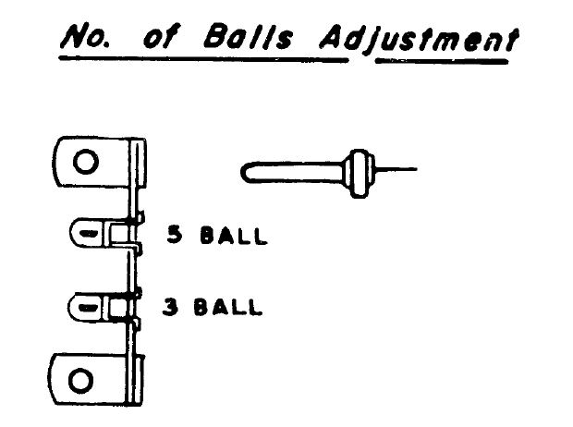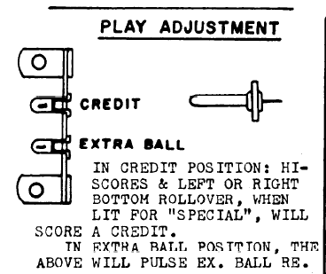

- Hi Score Adjustment Plug: make it lowest score possible (10,000), to replenish credits
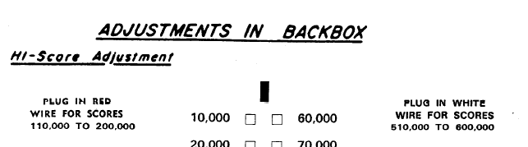
- Feature Adjustments: Conservative
- 