Williams Grand Prix

Physical Setup
- Level Machine – about 1% steeper than factory recommendation
- Ear Plug Tilt Hack
- Verify Tilt Sensitivity – should be sensitive, but only one danger with each hard bump
- Check Flipper Strength, Consider Glo Balls if playing too slow or can’t hit upper playfield
- Clean/wax playfield
- Clean glass

Switch Setup
- 5-Ball Play
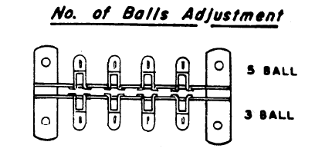
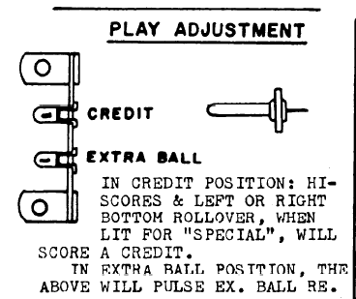
- Extra Balls – credits, not EB

- Hi Score Adjustment Plug: make it lowest score possible (10,000), to replenish credits
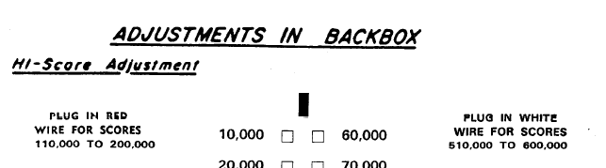
- Feature Adjustments: 2 and Conservative
- 