Stern Big Game
- Level Machine
- Verify Tilt Sensitivity
- Verify Volume
- Check Flipper Strength. Consider Glo-ball if flippers weak or play is too slow.
- Clean Playfield if necessary
- Clean Glass

Switch or Software Setup
- 3-Ball Play. SW7=OFF.
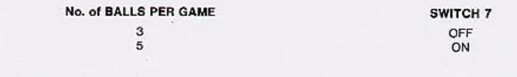
- Max Credits per coin (unless free play possible?).
  - S28-S25 ON, S2-5 ON, S1 OFF, S10-13 ON, S9 OFF. S17-S19 ON.
- Max Credits 40 (SW19=ON, SW18=ON). Credit Display = ?? (Off=Free Play?)
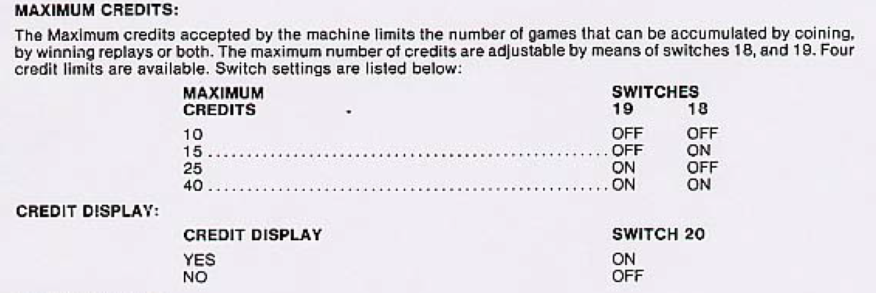
- No Extra Balls. SW17=OFF
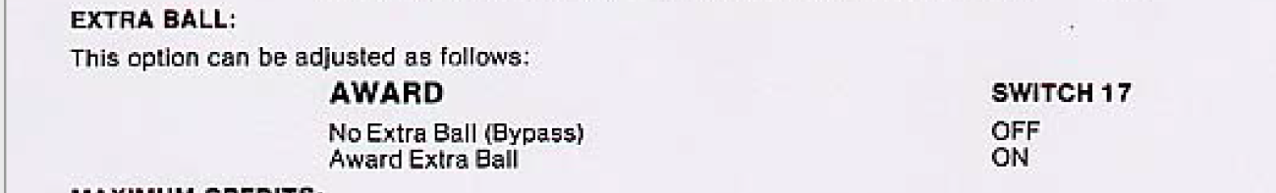
- Special is points SW31=ON, SW32=OFF.
- Card Selection Hard (SW23=ON). 5K per line = Ball 3 (SW25=ON,SW26=OFF).
