Stern Meteor

Physical Setup
- Level Machine, per factory recommendation
- Outlane Posts on Hard settings.
- Ear Plug Tilt Hack
- Verify Tilt Sensitivity – should be sensitive, but only one danger with each hard bump
- Verify no flipper disable when coin door opened.
- Check Flipper Strength, ensure ball can easily go to top of playfield.
- Clean Playfield if necessary
- Clean Glass
- Verify Volume

Switch or Software Setup
- 5-Ball Play for PinGolf, 3-Ball for Round E and Rookie
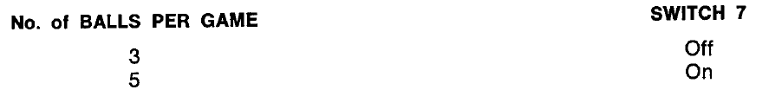
- Max Credits 40
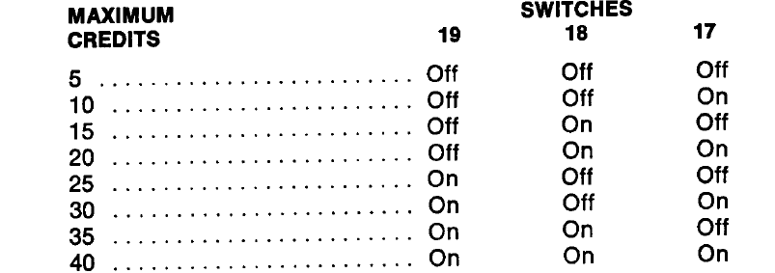
- 15 credits per coin:

- Special and WOW both worth points 130K/70K
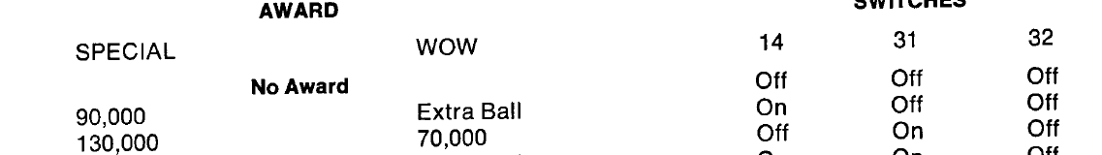
- Verify extra balls are off (WOW=points should do that)

