Sonic Cherry Bell
- Level Machine
- Verify Tilt Sensitivity
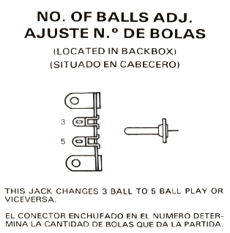
- Check Flipper Strength. Consider Glo-ball if flippers weak or play is too slow.
- Clean Playfield if necessary
- Clean Glass

Switch or Software Setup
- 5-Ball Play.
- Free Play if possible, else Max Credits per coin and minimum replay score
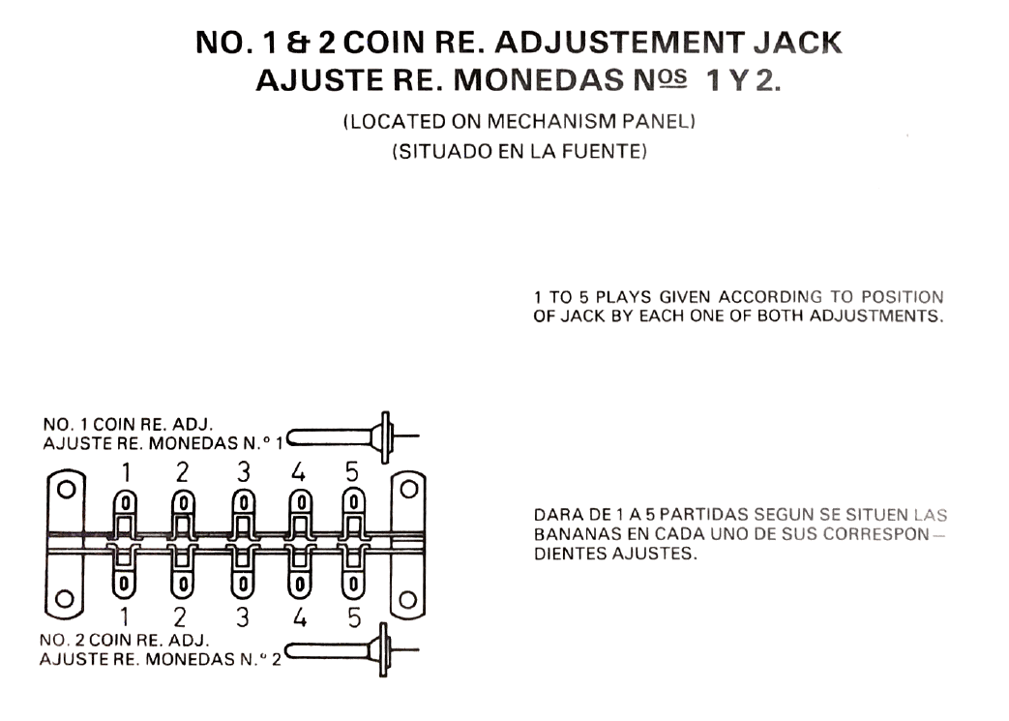 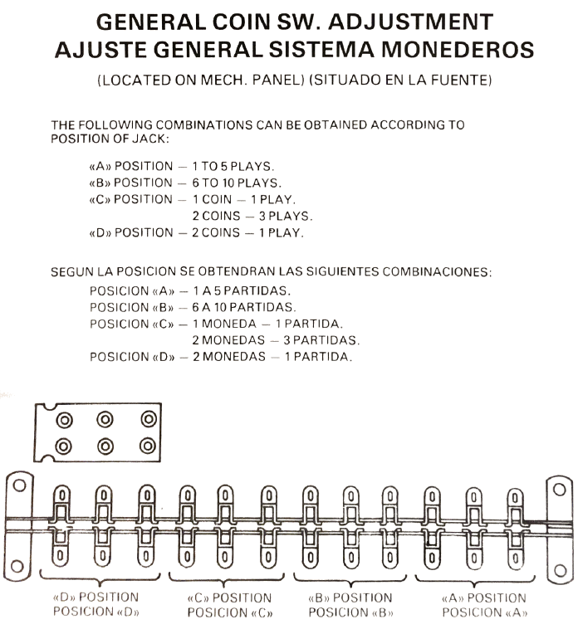
- Replay for Hi Scores, NOT Extra Ball
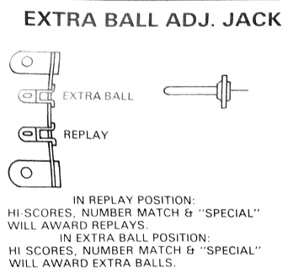
There was an issue with this setting, I think near infinite extra balls. If using this machine, play-test the choices.

