Classic Bank: Mars Trek

Physical Setup
- Level Machine
- Verify Tilt Sensitivity
- Check Flipper Strength
- Clean Playfield if necessary
- Clean Glass

Switch or Software Setup
- 5-Ball Play.
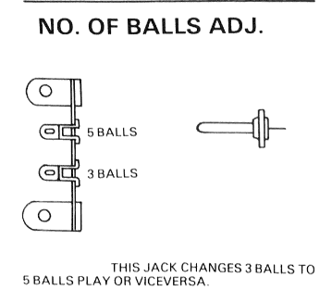
- Disable Extra Balls
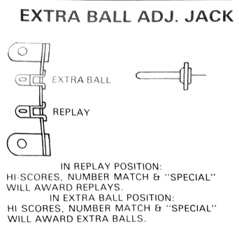
- Special worth points
- Free Play if possible, else Max Credits per coin and minimum replay score
- 