Gottlieb Pink Panther
- Level Machine
- Verify Tilt Sensitivity
- Verify Volume
- Check Flipper Strength. Consider Glo-ball if flippers weak or play is too slow
- Clean Playfield if necessary
- Clean Glass

Switch or Software Setup (These settings are from Gottlieb Black Hole; could be wrong)
- 3-Ball Play (Switch 17 off)
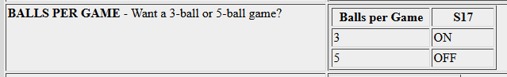
- Disable Extra Balls, Specials worth points instead of credits
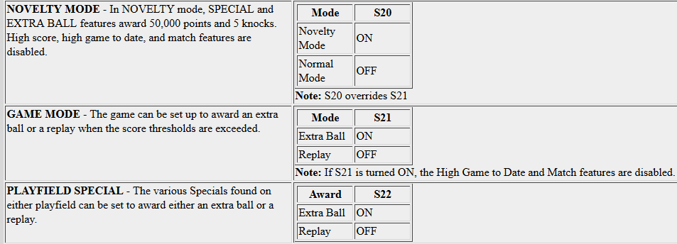
- Free Play if possible, else Max Credits per coin and minimum replay score

 