Cybernaut

Physical Setup
- Level Machine, normal steepness
- Remove Outlane Posts for “Hard Settings”. I.e. most open.
- Ear Plug Tilt Hack
- Verify Tilt Sensitivity – should be sensitive, but only one danger with each hard bump
- Verify coin door ball save or no flipper disable when coin door opened.
- Clean Playfield if necessary
- Clean Glass
- Ensure Glo Ball is installed
- Check Flipper Strength, ensure left ramp and right upper targets are easily hittable from ball at rest.
- Verify Volume

Switch Adjustments
- 3 Balls per Game
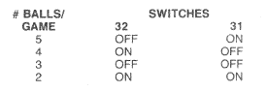
- Max Credits 40
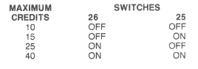
- 14 Credits per coin (unless you can put it on free play?)
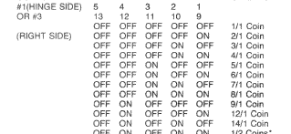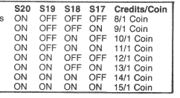
- Novelty (points for EB and Special)
- 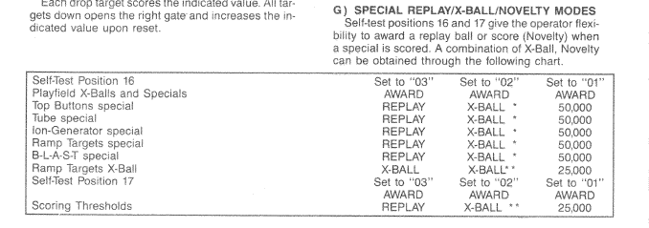
- No Bonus X on collect bonus
- 