Flash Gordon

Physical Setup
- Level Machine, per factory recommendation
- Outlane Posts on Medium settings.
- Ear Plug Tilt Hack
- Verify Tilt Sensitivity – should be sensitive, but only one danger with each hard bump
- Verify no flipper disable when coin door opened.
- Check Flipper Strength, ensure ball can easily go up ramps from stopped ball.
- Clean Playfield if necessary
- Clean Glass
- Verify Volume

Switch or Software Setup
- 5-Ball Play for PinGolf, 3-Ball for Round E and Rookie
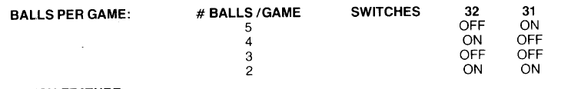
- Disable Extra Balls, Special worth points
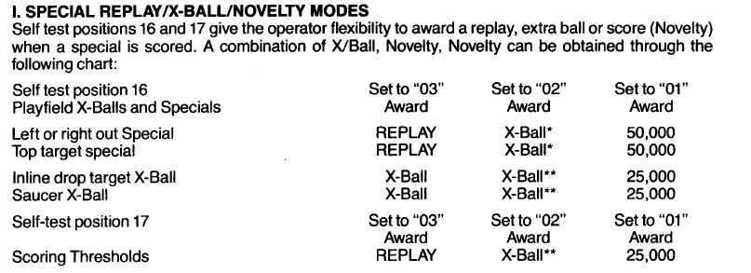
- Max Credits to 40: SW25 ON, SW26 ON
- 15 Credits per Coin,
- 