Centaur

Physical Setup
- Level Machine
- Outlane Posts on “Hard Settings”. I.e. most open.
- Verify Tilt Sensitivity
- Ear Plug Tilt Hack (see photo)
- Verify Volume
- Verify coin door ball save or no flipper disable when coin door opened.
- Clean Playfield if necessary
- Clean Glass
- Check Flipper Strength

Switch Setup
- #1-5, #9-13 Free Play if possible. Otherwise, set to Max Credits for Minimum Coins
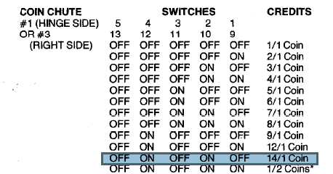
- #6 OFF Multipliers Reset
- #7 OFF Only 20-40-60 held
- #8 OFF Drop Conservative
- #14 OFF Feature lights reset
- #15 OFF Lit orbs are reset
- #16 OFF Guardians can only release one ball
- #21 OFF Release on last ball conservative
- #22 OFF Player must earn all orbs
- #23 ON Ball Tilt
- #24 OFF Target must be qualified on each ball
- #25,#26 ON ON, Max 40 credits
- #31, #32 OFF OFF, 3 Balls per game

Front Door Game Adjustments
- Self-Test Position 16: Set to 03 for Replay on Everything
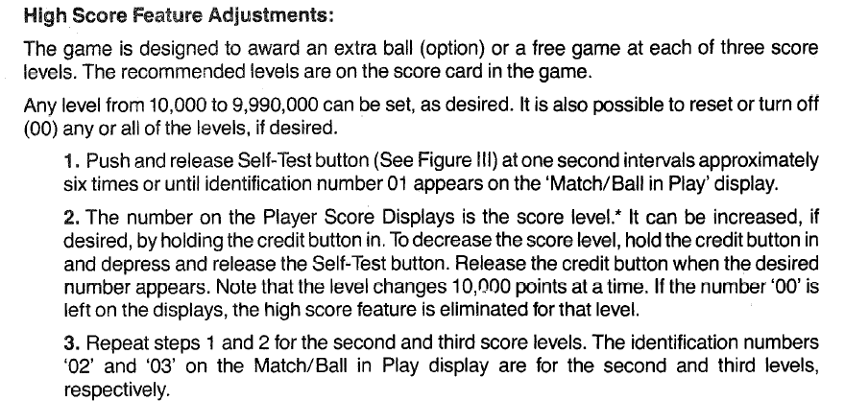
- Set all replay scores to 10K

