Six Million Dolar Man

Physical Setup
- Level Machine – about 1% steeper than factory recommendation
- Ear Plug Tilt Hack
- Verify Tilt Sensitivity – should be sensitive, tilt with each hard bump
- Check Flipper Strength, Consider Glo Balls if playing too slow or can’t hit upper playfield
- Clean playfield if necessary
- Clean glass

Switch or Software Setup
- 5-Ball Play (S16 ON).

- Major Mode Fature: Novelty
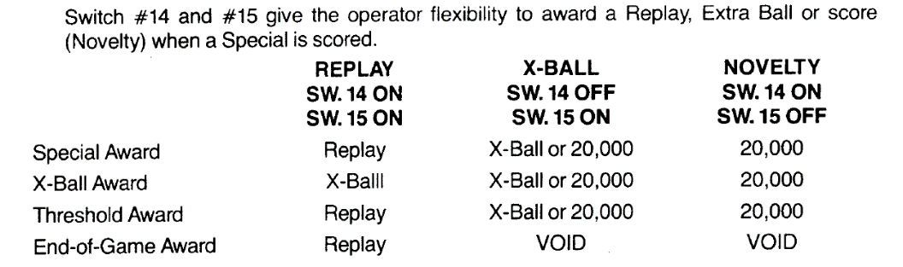
- Conservative
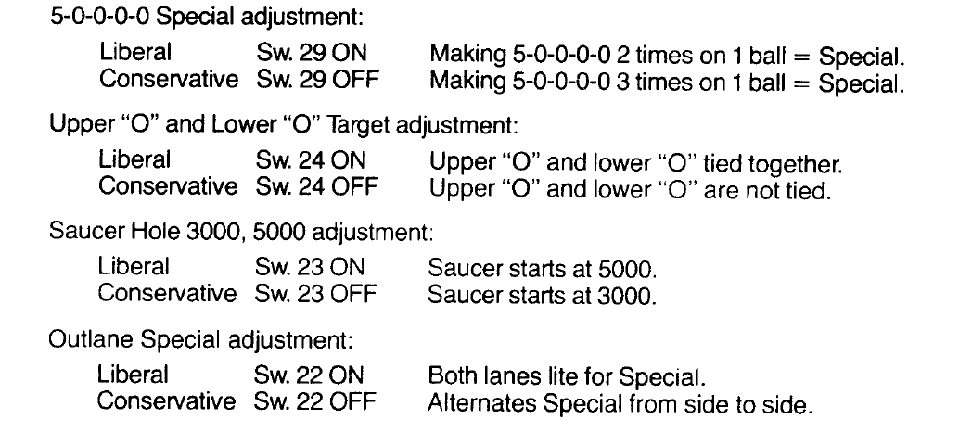

- Set Replay to 10K. Max 40 credits.
- 