Paragon

Physical Setup
- Level Machine
- Verify Tilt Sensitivity
- Check Flipper Strength
- Clean Playfield if necessary
- Clean Glass

Switch or Software Setup
- 5-Ball Play (S16 ON)

- Disable Extra Balls, Special worth points (S14 OFF, S15 OFF)
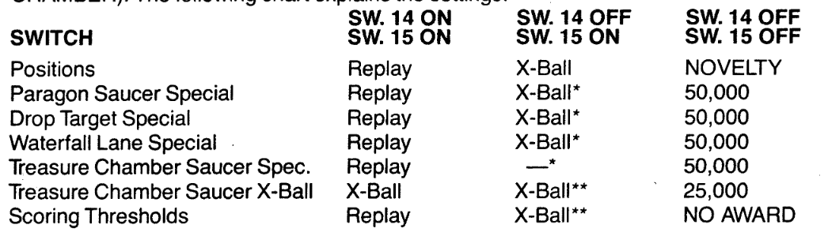
- To balance out inline-drops-all-day strategy, make that conservative, everything else liberal
- Paragon Saucer - Liberal (S23 ON, S24 ON)
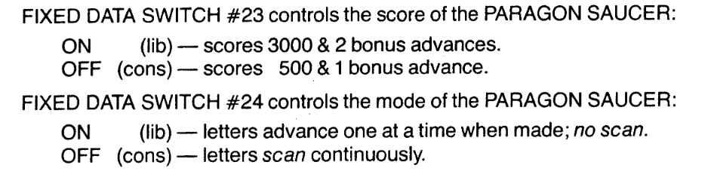
- Inline drops - Conservative (S30 OFF, S22 OFF)
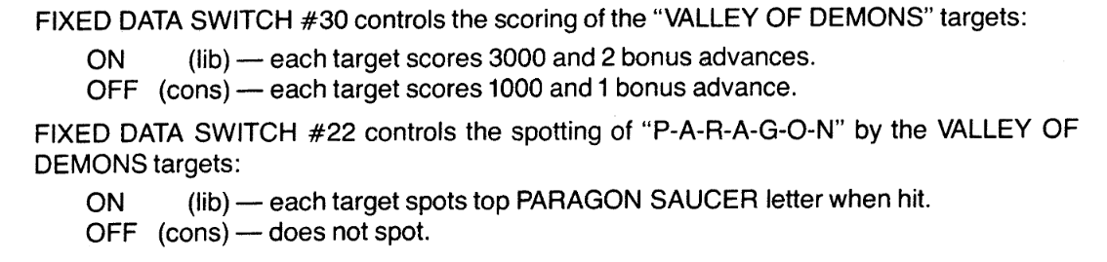
- 3-Bank drops – Liberal (SW31 OFF)
- Free Play if possible, else Max Credits per coin
  - Same as Mata Hari

