Nitro Groundshaker

Physical Setup
- Level Machine – about 1% steeper than factory recommendation
- Ear Plug Tilt Hack
- Verify Tilt Sensitivity – should be sensitive, but only one danger with each hard bump
- Check Flipper Strength, Consider Glo Balls if playing too slow or can’t hit upper playfield
- Clean/wax playfield
- Clean glass

Switch or Software Setup
- 3-Ball Play (S31 ON).

- Disable Extra Balls, Special worth points (SW6 ON, SW7 ON)
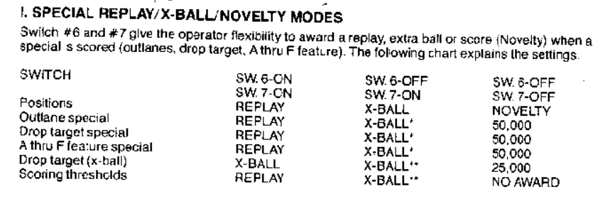
- Free Play if possible, else Max Credits per coin
  - Same as Mata Hari

