Mata Hari

Physical Setup
- Level Machine – about 1% steeper than factory recommendation
- Ear Plug Tilt Hack
- Verify Tilt Sensitivity – should be sensitive, but only one danger with each hard bump
- Check Flipper Strength, Consider Glo Balls if playing too slow or can’t hit upper playfield
- Clean/wax playfield
- Clean glass

Switch or Software Setup
- 3-Ball Play (S16 ON)

- Disable Extra Balls, Special worth points (S30/S31 OFF)
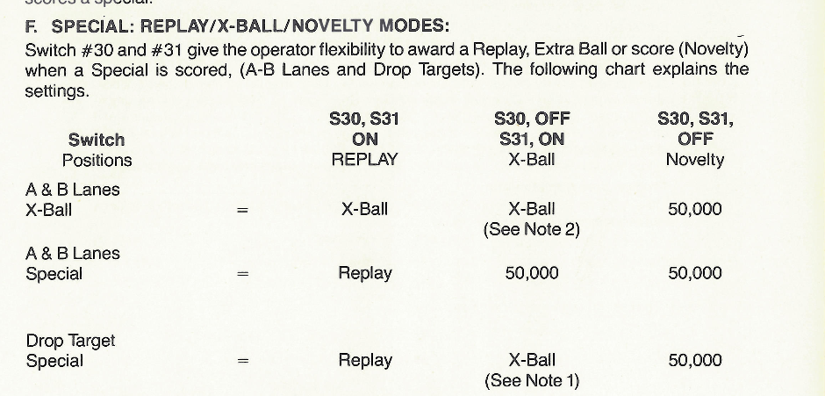
- AB Feature Conservative (S24 OFF)
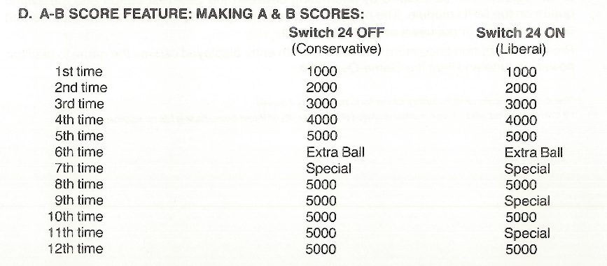
- Free Play if possible, else Max Credits per coin and minimum replay score
  - S28-S25 ON, S2-5 ON, S1 OFF, S10-13 ON, S9 OFF.
