Bally Eight Ball
- Level Machine
- Verify Tilt Sensitivity
- Verify Volume
- Check Flipper Strength. Consider Glo-ball if flippers weak or play is too slow.
- Clean Playfield if necessary
- Clean Glass

Switch or Software Setup
- 5-Ball Play (S16 ON)

- Disable EB, Hard Settings (S24 OFF, S23 OFF, S31 OFF, S22 OFF, S30 OFF )
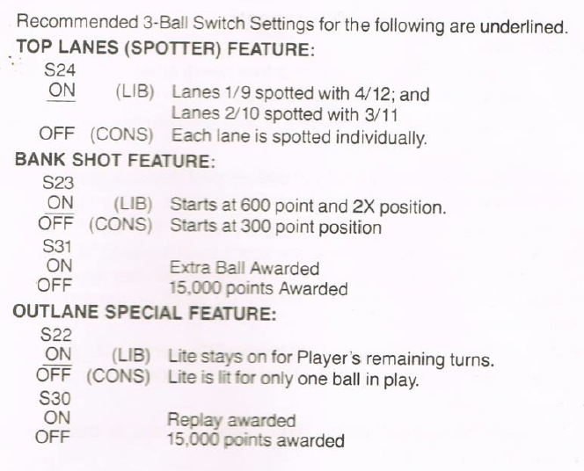
- Max 40 Credits
  - S17-19 ON
- Max Credits per coin (unless free play possible?).
  - S28-S25 ON, S2-5 ON, S1 OFF, S10-13 ON, S9 OFF. S17-S19 ON.
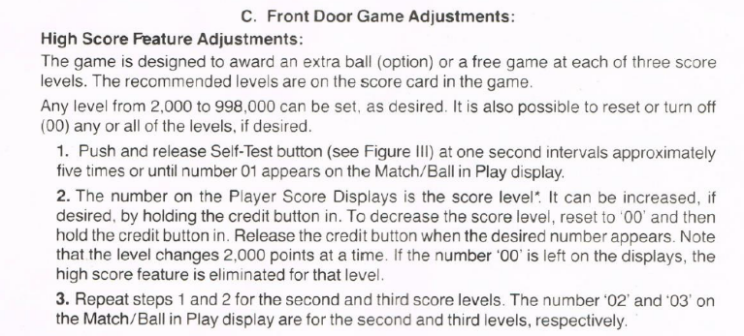
- Replay at 2K.

