Bally Old Chicago

Physical Setup
- Level Machine – about 1% steeper than factory recommendation
- Playfield Panel Post Adjustment: HARD
- Ear Plug Tilt Hack
- Verify Tilt Sensitivity – should be sensitive, but only one danger with each hard bump
- Check Flipper Strength, Consider Glo Balls if playing too slow or can’t hit upper playfield
- Ensure center eject is not easily exploitable; needs to be hard kickout. Use glo ball if needed.
- Clean/wax playfield
- Clean glass

Switch Setup
- 5-Ball Play

- Extra Balls – disable if possible (drop target Adjustment Plug)
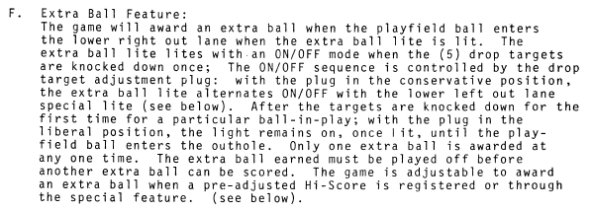
- Hi Score Adjustment Plug: make it lowest score possible, to replenish credits
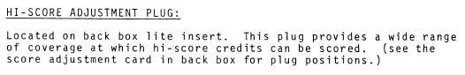
- Double Bonus Feature: 1,3,5 on a 5-ball game
- 

