Flip Flop

Physical Setup
- Level Machine, per factory recommendation
- Outlane Posts on Medium settings.
- Ear Plug Tilt Hack if doable
- Verify Tilt Sensitivity – should be sensitive, but only one danger with each hard bump
- Verify no flipper disable when coin door opened.
- Check Flipper Strength, ensure ball can easily go to top of playfield.
- Clean Playfield if necessary
- Clean Glass
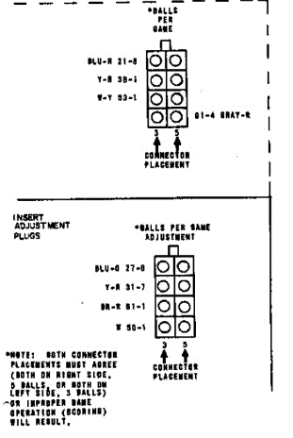
- Verify Volume

Switch or Software Setup
- 5-Ball Play
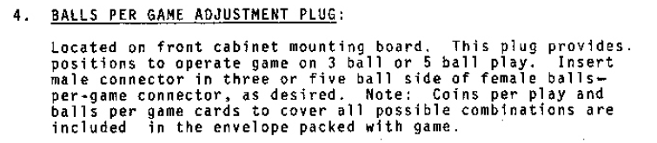
- Disable Extra Balls, Special worth points (SW6 ON, SW7 ON)
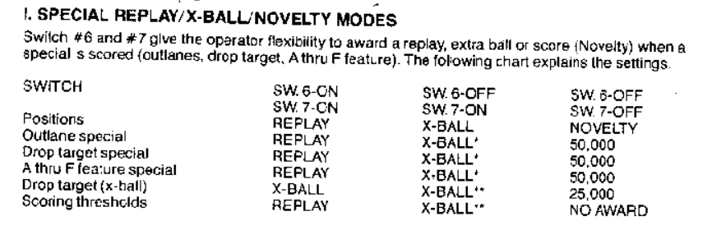
- Max coins per chute
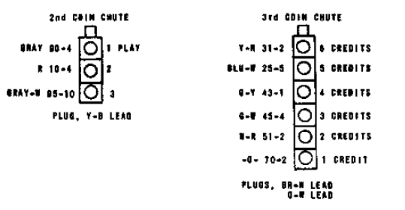
- Low replay score

