Monte Carlo

Physical Setup
- Level Machine, per factory recommendation
- Outlane posts on Medium
- Ear Plug Tilt Hack if it makes sense
- Verify Tilt Sensitivity – should be sensitive, tilt with each hard bump
- Verify no flipper disable when coin door opened.
- Check Flipper Strength, ensure ball can easily go to top of playfield. Consider Glo Balls.
- Clean Playfield if necessary
- Clean Glass
- Verify Volume

Hardware Setup
- 5-Ball Play.
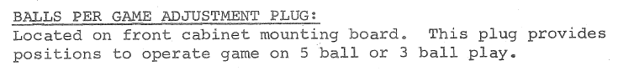
- Leave Extra balls enabled for PinGolf. If lots of EBs are earned, disable them (give a credit) for Round E.
