Airborne Avenger

Physical Setup
- Level Machine, per factory recommendation
- Outlane Posts on Medium settings.
- Ear Plug Tilt Hack
- Verify Tilt Sensitivity – should be sensitive, but only one danger with each hard bump
- Verify no flipper disable when coin door opened.
- Check Flipper Strength, ensure ball can easily go to top of playfield. If not consider Glo Ball
- Clean Playfield if necessary
- Clean Glass

Switch or Software Setup
- 5-Ball Play for PinGolf, 3-ball for Round E and Rookie
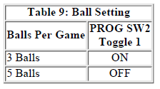
- Disable Extra Balls
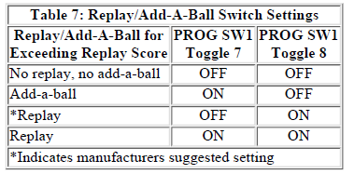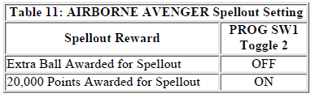
- Special is points
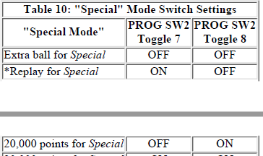
- 50K Replay Score: Rotary Switch to 0, Prog SW1 Toggle 4 OFF.
- Max 20 Credits
- 